Midterm 1

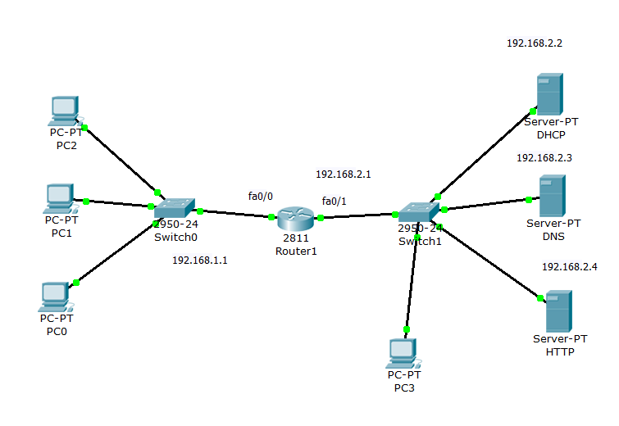

--- System Configuration Dialog ---

Continue with configuration dialog? [yes/no]: no

Press RETURN to get started!

Router>enable

Router#configure terminal

Enter configuration commands, one per line. End with CNTL/Z.

Router(config)#interface fastethernet 0/0

Router(config-if)#ip address 192.168.1.1 255.255.255.0

Router(config-if)#no shut down

Router(config-if)# exit

Router(config-if)#interface fastethernet 0/1

Router(config-if)#ip address 192.168.2.1 255.255.255.0

Router(config-if)#no shut down

Router(config-if)# exit

%LINK-5-CHANGED: Interface FastEthernet0/1, changed state to up

%LINEPROTO-5-UPDOWN: Line protocol on Interface FastEthernet0/1, changed state to up

Router#

%SYS-5-CONFIG_I: Configured from console by console

Router#configure terminal

Enter configuration commands, one per line. End with CNTL/Z.

Router(config)#

Router(config)#interface fastethernet 0/0

Router(config-if)#**ip helper-address 192.168.2.2**

Router(config-if)#no shut down

Router(config)# exit

**NM2FE2W To increase the port of 2960-24TT**

Midterm 2

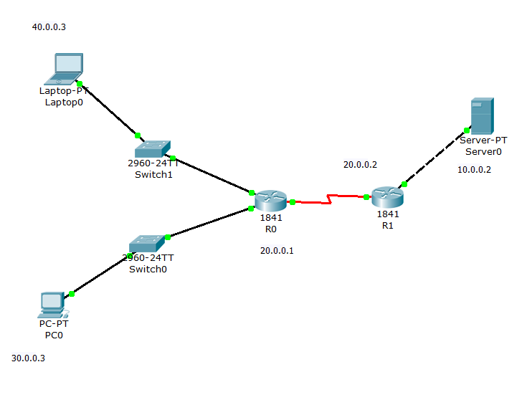

Router1

en

conf t

int fa0/0

ip add 10.0.0.2 255.0.0.0

no sh

ex

int se0/0/0

ip add 20.0.0.2 255.0.0.0

clock rate 64000

bandwidth 64

no sh

ex

ip route 40.0.0.0 255.0.0.0 20.0.0.1

ip route 30.0.0.0 255.0.0.0 20.0.0.1

ip nat inside source static 10.0.0.2 50.0.0.1

int fa0/0

ip nat inside

ex

int se0/0/0

ip nat outside

ex

Router0:

en

conf t

int fa0/0

ip add 40.0.0.3 255.0.0.0

no sh

ex

int fa0/1

ip add 30.0.0.3 255.0.0.0

no sh

ex

int se0/0/0

ip add 20.0.0.1 255.0.0.0

clock rate 64000

bandwidth 64

no sh

ex

ip route 50.0.0.0 255.0.0.0 20.0.0.2

ex